**CMPE 285 – Software Engineering Processes**

**Python Stock Profit Calculator**

**First Name:** Harish

**Last Name:** Marepalli

**SJSU ID:** 016707314

**Professor:** Richard Sinn

**Description**

The goal of this homework is to use Python to implement a stock profile calculator. Perform the following:

* Setup your Python development environment
* Research into how stock profit is being calculated.
* Implement a Python program that it will take the following inputs:
  + A stock symbol
  + Allotment (number of shares)
  + Final share price (in dollars)
  + Sell commission (in dollars)
  + Inital share price (in dollars)
  + Buy commission (in dollars)
  + Captial gain tax rate (in %)
* Output the following items after computation:
  + Proceeds (Allotment x Final share price)
  + Cost (Allotment x Initial Share Price + commissions + Tax on Capital Gain)
  + Net Profit (in dollars)
  + Return on investment (in %)
  + Break-even price (in dollars)

**Answer:**

Code:

# *----------Stock Profit Calculator----------*

# First Name: Harish

# Last Name: Marepalli

# SJSU ID: 016707314

# Professor: Richard Sinn

# This below function is used to calculate the Profile Report

def stockProfitCalculation(symbol, allotment, finalPrice, sellCommission, initialPrice, buyCommission, cptlGainTaxRate):

proceeds = allotment * finalPrice # Calculate proceeds

TaxOnCapitalGain = (proceeds - (allotment * initialPrice + buyCommission + sellCommission)) * (cptlGainTaxRate / 100) # Calculate tax on capital gain (allotment * initialPrice = Total Purchase Price)

costPrice = allotment * initialPrice + buyCommission + sellCommission + TaxOnCapitalGain # Calculate total cost

netProfit = proceeds - costPrice # Calculate net profit

ROI = (netProfit / costPrice) * 100 # Calculate Return On Investment

breakEvenPrice = (allotment * initialPrice + buyCommission + sellCommission) / allotment # Calculate break-even price

# Display the profit report

print("\nPROFIT REPORT:")

print("\nProceeds\n${:.2f}".format(proceeds))

print("\nCost\n${:.2f}".format(costPrice))

print("\nCost details:")

print("Total Purchase Price")

print("{} × ${} = ${:.2f}".format(allotment, initialPrice, allotment * initialPrice))

print("Buy Commission = ${:.2f}".format(buyCommission))

print("Sell Commission = ${:.2f}".format(sellCommission))

print("Tax on Capital Gain = {:.2f}% of ${:.2f} = ${:.2f}".format(cptlGainTaxRate, (proceeds - (allotment * initialPrice + buyCommission + sellCommission)), TaxOnCapitalGain))

print("\nNet Profit\n${:.2f}".format(netProfit))

print("\nReturn on Investment\n{:.2f}%".format(ROI))

print("\nTo break even, you should have a final share price of\n${:.2f}".format(breakEvenPrice))

if __name__ == "__main__":

print("Compute Your Profit:")

# Input vales from the user

symbol = input("\nTicket Symbol:\n")

allotment = int(input("\nAllotment:\n"))

finalPrice = float(input("\nFinal Share Price:\n"))

sellCommission = float(input("\nSell Commission:\n"))

initialPrice = float(input("\nInitial Share Price:\n"))

buyCommission = float(input("\nBuy Commission:\n"))

cptlGainTaxRate = float(input("\nCapital Gain Tax Rate (%):\n"))

stockProfitCalculation(symbol, allotment, finalPrice, sellCommission, initialPrice, buyCommission, cptlGainTaxRate)

Code Screenshot:

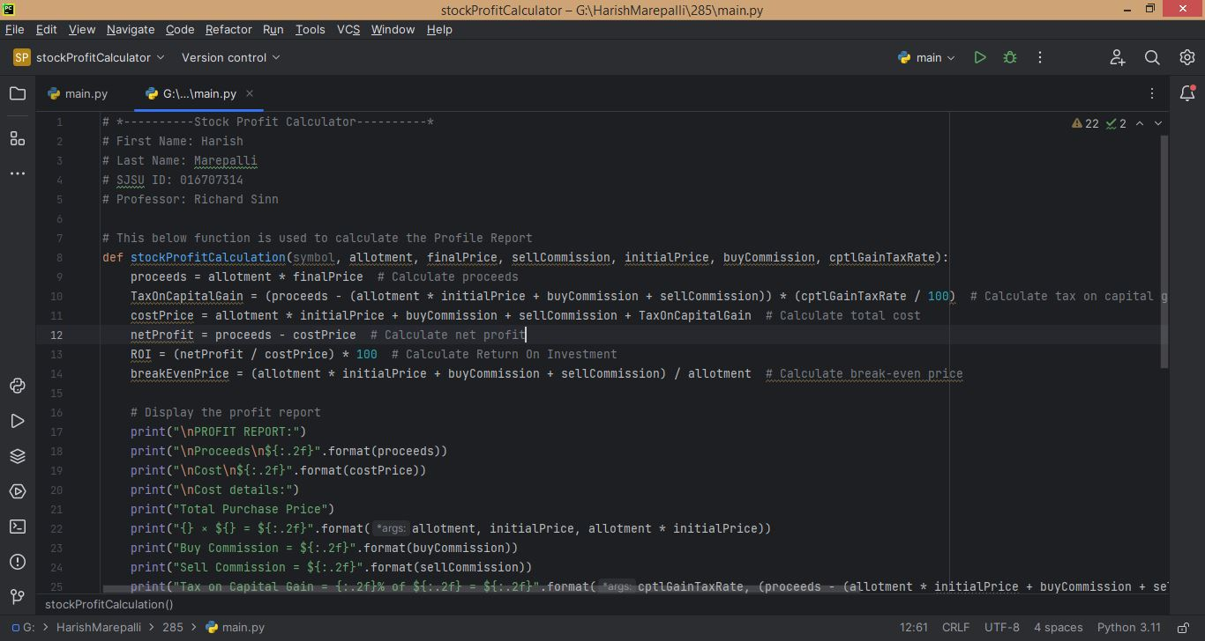

***Code Snippet 1***

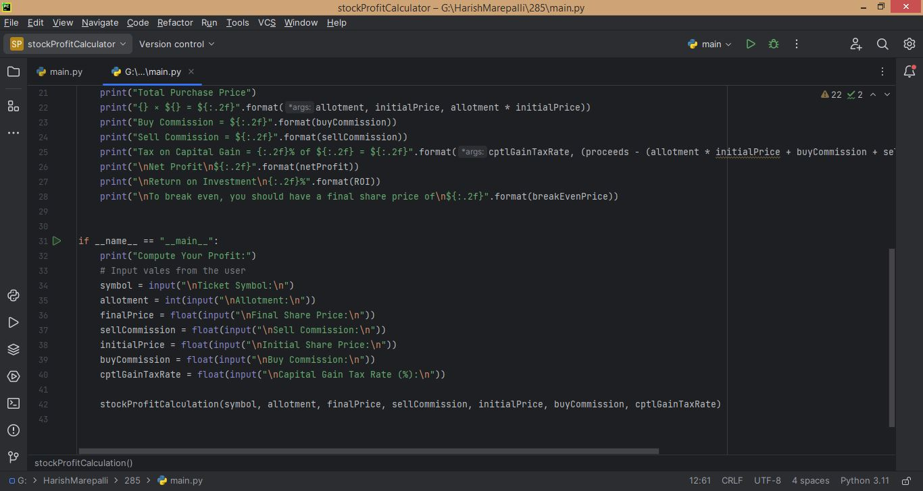

***Code Snippet 2***

Run/Console Snippets:

For Test case 1:

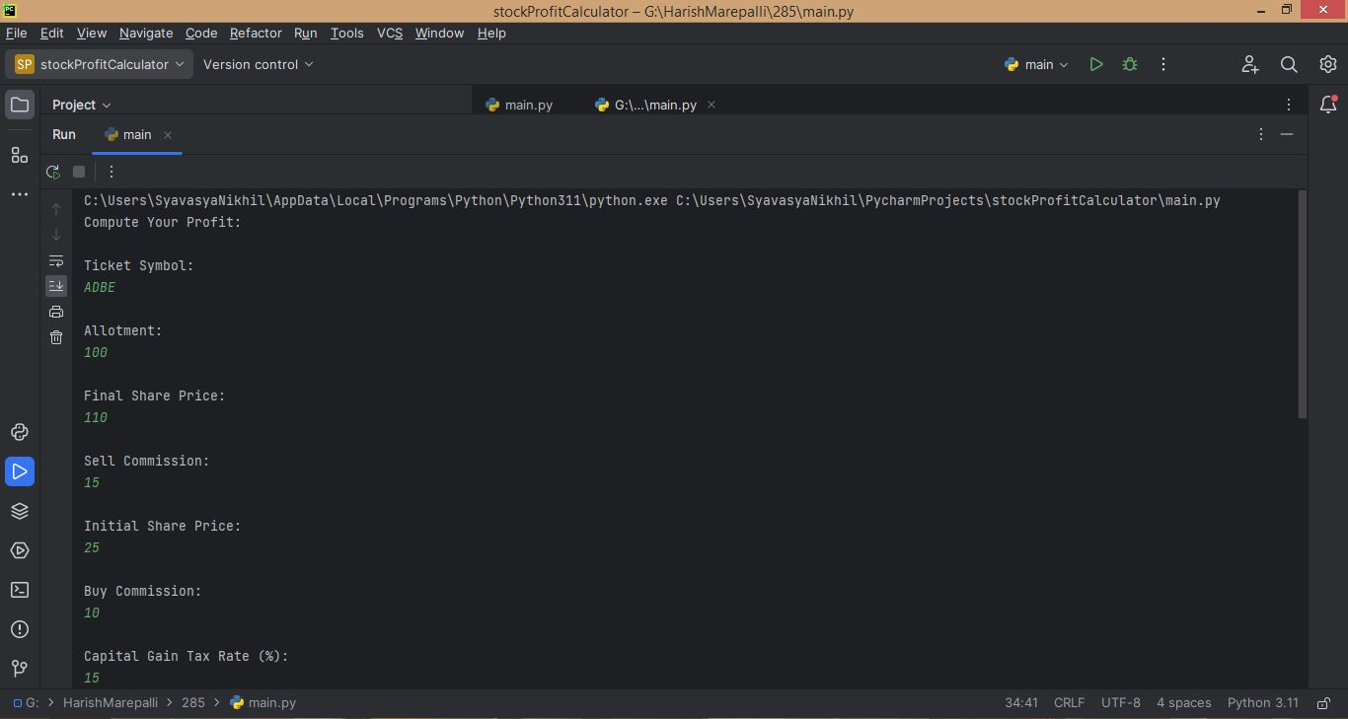

***Console Snippet Test Case 1***

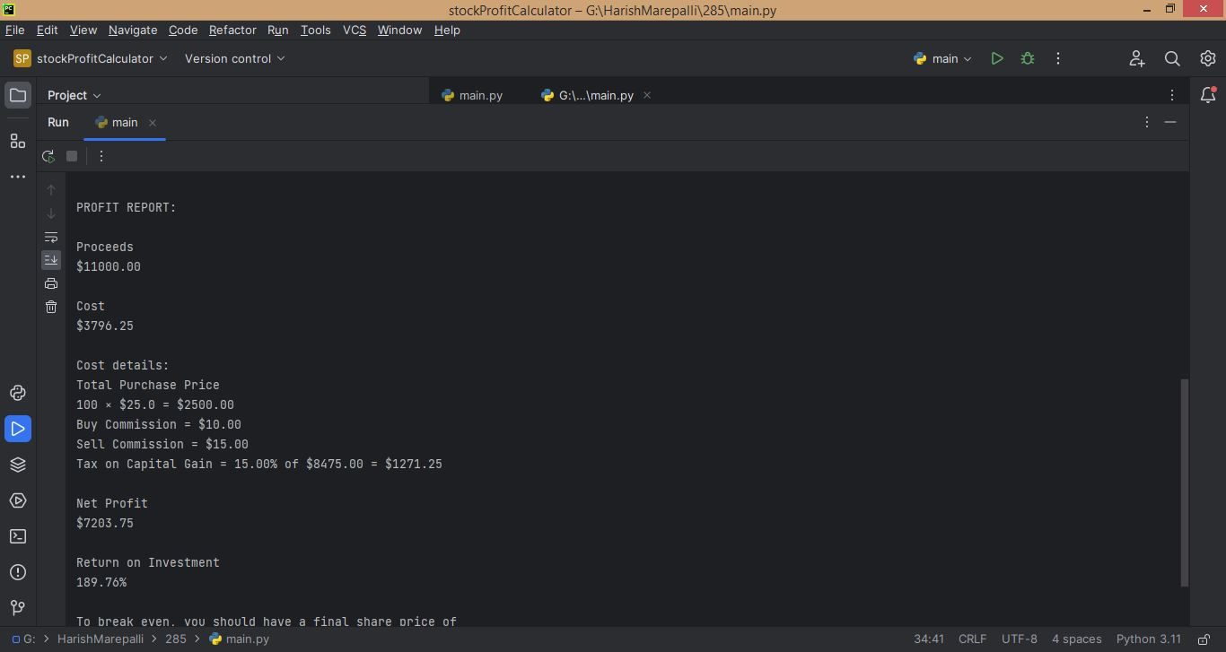

***Console Snippet Test Case 1***

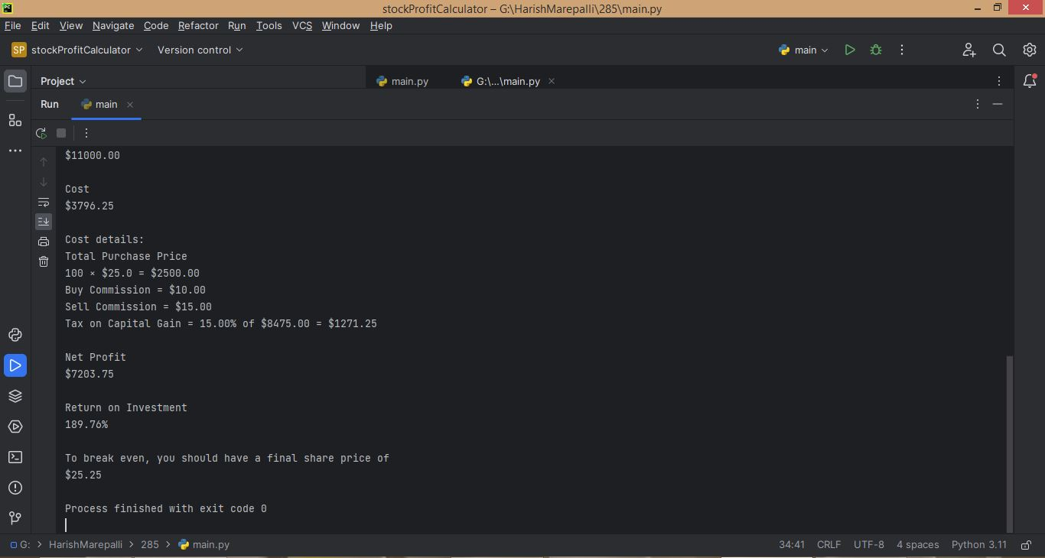

***Console Snippet Test Case 1***

For Test case 2:

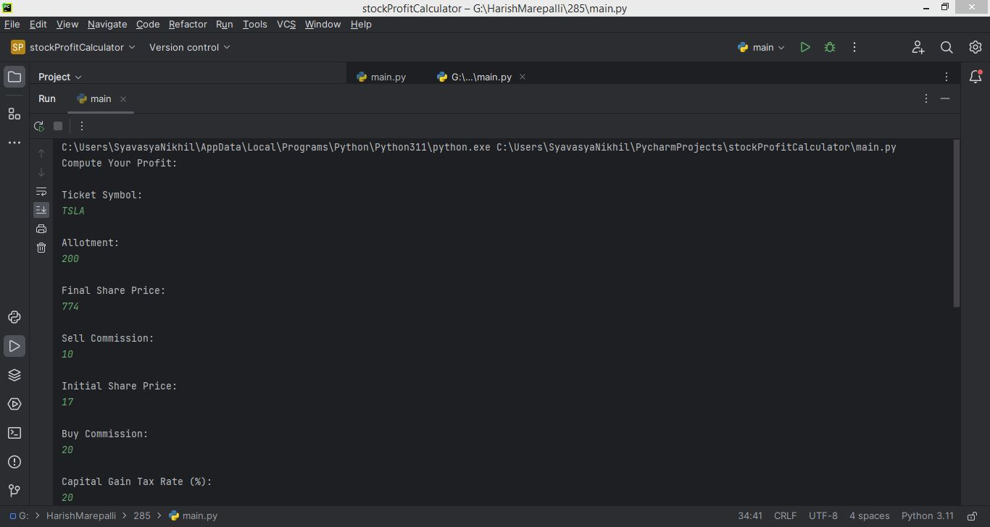

***Console Snippet Test Case 2***

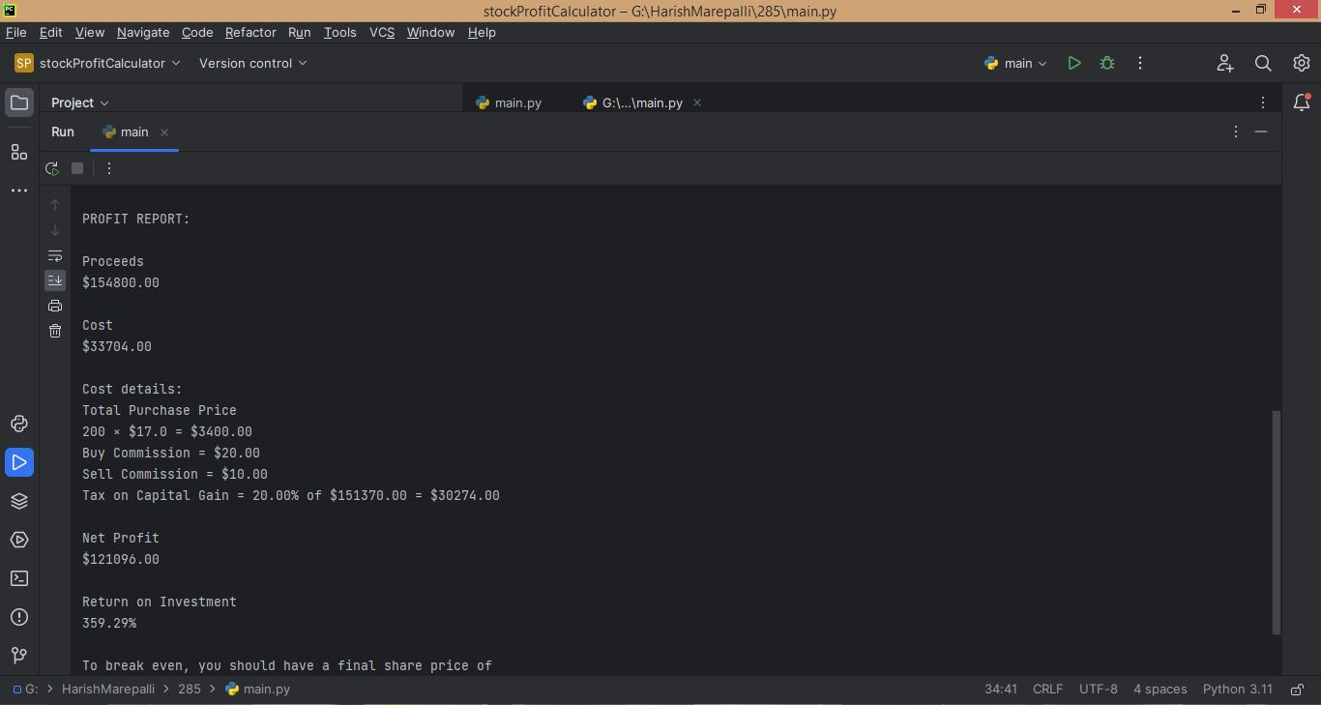

***Console Snippet Test Case 2***

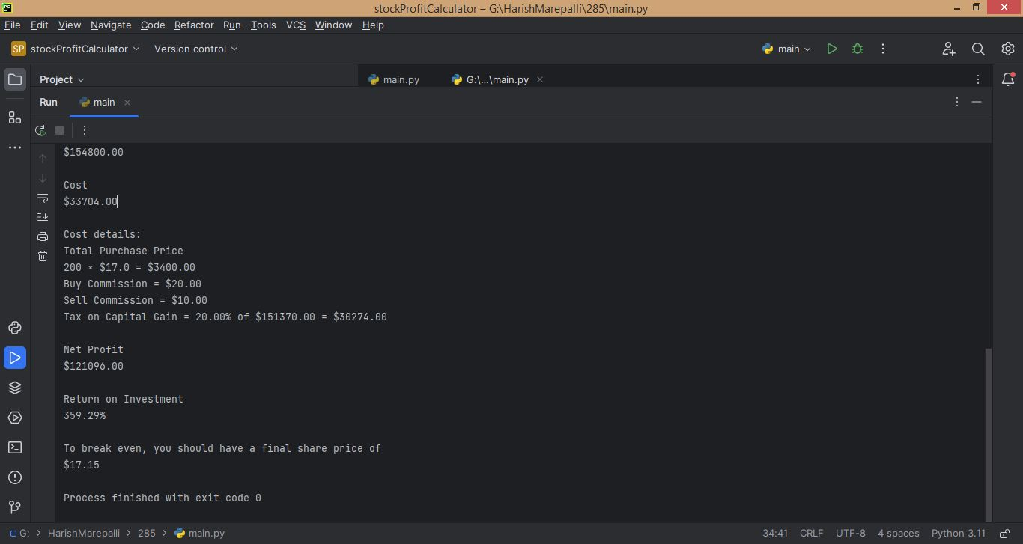

***Console Snippet Test Case 2***